PRESS CONFERENCE – PRESS RELEASE – JIFF 2019
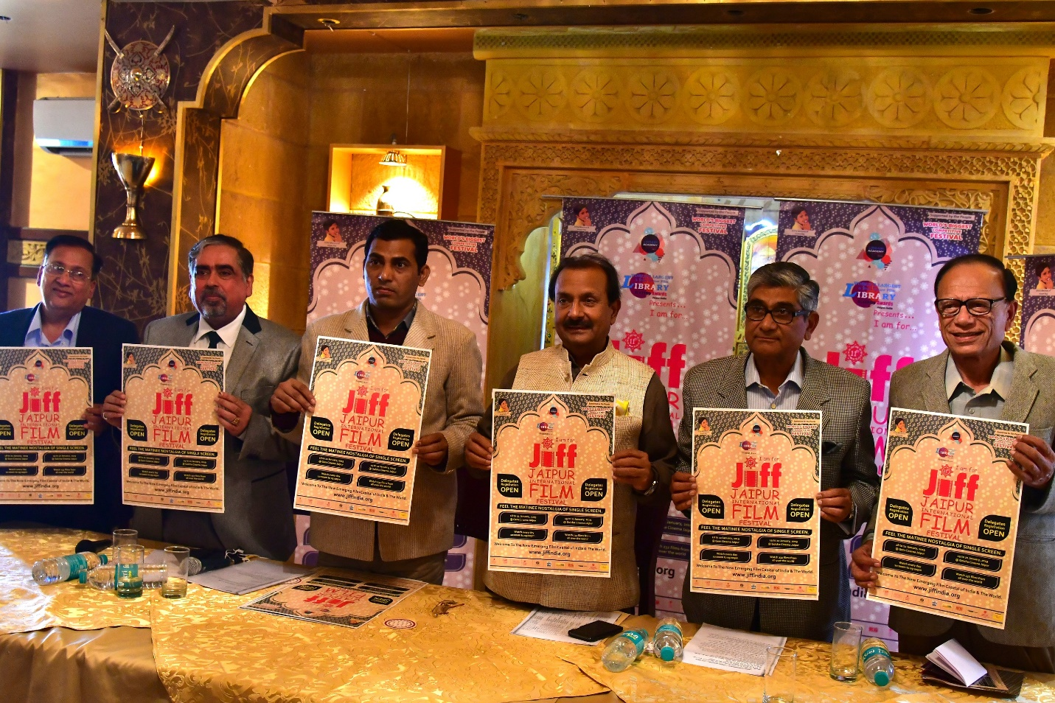
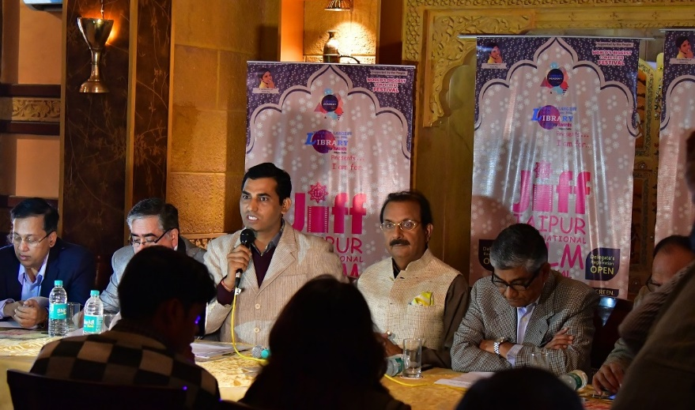

18th January will mark the beginning of the 11th Aryan JIFF from 5:00 PM at historical GEM Cinema.
25 Film Makers from 25 countries across the globe will simultaneously inaugurate the JIFF 2019.
GEM of Jaipur will be revived for JIFF.
232 films of 64 countries along with advantageous workshops, seminars and special chat sessions will be a part of JIFF.
7 venues will be the hub for JIFF 2019.
JIFF 2019 is World’s Biggest Competitive Festival.
JIFF has helped in providing recognition to Tourism, Art & Culture of Rajasthan & India on a broader perspective.
Delegate Registration is compulsory.
Main Venue for JIFF-2019 will be GEM Cinema this year.

Jaipur: Let us tie our seat belts and kick start for an audacious journey of films from 18th to 22nd January. It’s time to unveil the 11th edition of JIFF- The Aryan Jaipur International Film Festival-JIFF. The grand inauguration of JIFF 2019 is all set to take place at the historical movie theatre, GEM Cinema at 5:00pm on 18th January 2019. Film makers, actors, directors, producers and writers from every nook and corner of the world are expected to come in Jaipur for attending JIFF 2019. The main venue for JIFF 2019 will be GEM Cinema.
25 Film Makers from 25 countries across the globe will simultaneously inaugurate the JIFF 2019 – Rajeev Arora, Chairman JIFF.
The inauguration of JIFF 2019 will not only be grand but magnificent and splendid too. First time in JIFF 2019 we will have amongst us guests from around the globe in large numbers. The JIFF Organizing Committee has invited film directors, producers, writers, actors and actresses from 25 different countries. We have received their consent for the same. The invited guests will be from France, Iran, Pakistan, Sri Lanka, USA, South Africa, Afghanistan, Bangladesh, Bosnia & Herzegovina, Brazil, Cambodia, Canada, Germany, Italy, Mauritius, Nepal, Nigeria, Peru, Romania, Serbia, Singapore, Switzerland, Tunisia, U.K. and Yemen.
GEM of Jaipur will be revived for JIFF – Sudhir Kasliwal
GEM was Rajasthan’s first 70 mm single screen with better sound quality. The GEM Cinema was out of existence since 2005. There was a period when people loved and preferred watching movies in GEM than in Rajmandir. Its 90x40 feet balcony without any pillar was a matter of great amusement to people. After 14 years it has been revived for JIFF and necessary restoration work has been started by Sh. Sudhir Kasliwal. In the era where single screen theatres are being closed, the opening of GEM Cinema is a plucky but fruitful task. It will mark the restoring of the old charm of the curtain raiser in the cinema hall will the glittering of colorful lights. GEM Cinema was started on 4th July 1964 with showcasing Dharmendra and Mala Sinha starrer Pooja Ke Phool. It was inaugurated by the then Chief Minister Sh. Mohanlal Sukhadiya and Ramniwas Mirdha. It was designed by P K Loriya and was constructed by famous photographer Sudhir Kaliwal’s father Sh.Laxmi Kumar Kasliwal.
Workshops, seminars and distinct chat sessions will be the special attraction at JIFF – Rajendra Bora, Spokesperson, JIFF.
Along with the screening of 232 films there will be workshops, seminars, master classes and special chat sessions at JIFF 2019. The poster exhibition will start on 19th January from 11:30am at Gem Cinema, followed by opening of Film market by the film Baokchambab from Cambodia at 12:30pm. The Sridevi JIFF Indian Panorama will begin at 3:30pm with the movie Kasaai directed by Gajendra Shotriya.
The largest International Co-Production Meet at the festival is scheduled to happen on 20th January at 5:30pm at Gem Cinema. The Light a Lamp program of lighting 2100 lamps for World’s Largest & Most Secure Film Library & International Cinema Centre will take place on 21st January from 4:00 pm at Gem Cinema.
Films can be seen in 10:00am, 12:30pm, 3:30pm and 6:30pm shows – Hanu Roj, Founder.
The day by day screening schedule of JIFF was released on 21st December. 232 films from 64 countries will be screened in Gem Cinema, Nile & Tivoli halls of Golcha Cinema in 10:00am, 12:30pm, 3:30pm and 6:30pm shows. Special shows for youth have been put up with movies in English, Hindi and other languages. There will be 10:00am and 12:30 pm shows dedicatedly for school students. The schools can book their shows accordingly for their students.
7 venues will be the hub for JIFF 2019 – Nand Kishore Jhalani, JIFF Organizing Committee Member.
The closing ceremony will be on 22nd January at Golcha Cinema from 5pm with the award ceremony. The festival will occur from 18th to 22nd January at 7 different venues, Gem Cinema, Golcha Cinema, Rajasthan Adult Education Association, Dolphins High School- Pratap Nagar, Biyani Girls College, Birla Institute Of Technology. The main venue for JIFF will be GEM Cinema.
JIFF 2019 is World’s Biggest Competitive Festival – Dr. Esh Munjal, JIFF Organizing Committee Member.
The 11th edition of JIFF is on its way to create history by being the World’s Biggest Competitive Festival. 227 films of 64 countries are there in the competition among these 41 are feature fiction and 129 are short fiction films. This makes JIFF the first festival with largest film selection in the world.
JIFF 2019 has 41 feature films from 23 countries, 18 documentary feature films from 14 countries, 14 short documentary films from 8 countries, 11 animation films from 9 countries, 1 audio music and 4 music videos from 4 countries, 129 short fiction films from 39 countries, 9 mobile films from 3 countries, 8 web series from 3 countries. There are 13 films from Rajasthan. 5 films will not be screened during the festival among the total nominated films.
Recognition to Tourism, Art & Culture of Rajasthan & India on a broader perspective.
JIFF has established Jaipur as the new film capital of the country. With constant efforts of JIFF, the Tourism, Art & Culture of Rajasthan & India have gained recognition on both global and national perspective.
Delegate Registration is compulsory.
In order to take part in all the activities at JIFF, the delegate registration is compulsory. Student registration is free in the memory of Aryan Roj. School students are entitled to be given entry in the shows designed for them. The entry fee for visitors is INR 100 for one show, INR 200 for one day and INR 500 for five days. For registration and festival schedule visit: www.jiffindia.org
For more information visit: www.jiffindia.org
IN PHOTO L to R : Mr. Nand Kishore Jhalani, Dr. Ish Munjal, Mr. Hanu Roj, Mr. Rajiv Arora, Mr. Sudhir Kasliwal and Mr. Rajaendra Boda.

Best Regards
Rajendra Bora
Spokesperson: Jaipur International Film Festival – JIFF
M: + 91-9829051075 I O: +91-141-4055263
Off: +91-141- 4055263 Mob: +91-9828934481/8003937961
Website: www.jiffindia.org

RSVP: Ms. Yashika Pareek (Assist Director) - 8003937961

